Tara Magnet High School Athletic Handbook



Welcome to Tara Magnet High School Athletic Department! Our mission is to promote student-athlete development, teamwork, and sportsmanship. We are excited to support you in your athletic journey and look forward to a successful season

# MISSION STATEMENT

**Look:** Student athletes will be able to see in all coaches the example we want them to follow.

**Live:** All coaches will walk in a manner that reflects behavior worthy to be followed.

**Leave:** All coaches will teach and model with compassion what will deposit in each student-athlete something inherently good that will positively impact their lives when they depart from Tara High School.

# PHILOSOPHY

The Tara High School Administration, Athletic Department, Faculty and Staff believe a competitive athletic department is a contributing factor in the overall educational program of the school.

To maximize our effectiveness, the athletic program must be closely coordinated with the general instructional program of the school. It must be such that the number of students accommodated, and the educational aims achieved, justify its inclusion in the overall educational program. It must also be based on the spirit of amateurism, so participation is regarded as a privileged opportunity.

Athletics are for all students who are physically able to participate, who qualify under eligibility requirements, and who adhere to the rules set forth by the state and local school officials. We believe that participation will contribute to the following:

1. Improvement of the health, fitness and general welfare of all individuals taking part in the program.
2. Engage a maximum number of students in active areas of the program.
3. Stimulate all participants to achieve creditable academic progress and to contribute to the general educational program of the school.

# OBJECTIVES OF THE ATHLETIC PROGRAM

1. **EDUCATION COMES FIRST** – Athletics, being part of the total educational process, will place high emphasis on scholarship in all phases of the school environment.
2. Athletics will provide opportunity for students to enjoy one of America’s greatest traditions…. The privilege of competitive sports/activities.
3. Athletics will provide a “whole school” interest in activities which will develop school spirit and bring students other than athletes into the program.
4. Athletics will teach new skills and offer opportunities to improve those already possessed.
5. Athletics will teach students habits of health, sanitation, and safety.
6. Athletics will provide opportunities for lasting friendships with teammates and opponents to develop.
7. The athletic program will provide opportunities for students to observe and exemplify good sportsmanship.
8. The athletic program will aid in leadership training and discipline which will follow the student-athlete throughout their life.
9. The athletic program will provide an opportunity for students to place group above self; to learn of the need to have and follow rules and regulations.
10. The athletic program will consider interscholastic athletics as extended opportunities for deserving individuals to continue their athletic and academic careers beyond the high school level.

# COACHES BILL OF RIGHTS

* + Coaches have the right to feel safe while coaching
    - At no time should a coach feel that their safety is at risk.
  + Coaches have the right to be treated respectfully.
    - Coaches should be approachable and open to communication with parents, but they are not obligated to tolerate aggressive or abusive treatment.
  + Coaches have the right to demand commitment from their players.
    - Coaches know other obligations interfere with a player’s ability to attend every practice/game, but consistent absenteeism is disruptive to the team and should be discussed with the coach in advance.
  + Coaches have the right to a life outside of athletics.
    - Coaches are not required to respond to every text, call, or email received by parents. Coaches should inform parents of their availability and preferred means of communication.
  + Coaches have the right to dismiss a player from the field, court, or bench area if they are unable to behave appropriately.
    - Coaches are responsible for the safety and development of all the players and may remove a player who is being disruptive or creating an unsafe environment or situation.
  + Coaches have the right to be informed of any information that may affect their ability to coach a player successfully.
    - Coaches must respect and understand that parents have the right to maintain their child’s privacy, but some situations should be shared with the coach that require special needs, medical issues, or family-related stress.
  + Coaches have the right to receive support from parents.
    - Parents will not agree with every decision, and coaches must be open to receiving respectful and constructive feedback from parents.
  + Coaches have the right to autonomy.
    - If coaches observe the guidelines set by administration, school district, and LHSAA, coaches should be able to make their own decisions regarding practice planning, scheduling, and game strategy.
  + Coaches have the right to receive support from administrators and leadership.
    - If a coach encounters a problem that they cannot resolve on their own, they should seek and receive help from the appropriate personnel.
  + Coaches have the right to receive training.
    - Coaches should have access to formal and informal training opportunities that will help them achieve success.

## Coaching Descriptions and Evalutions

**Job Title**: Head Coach

**Supervisor:** Principal & Athletic Director

##### Job Summary

Position is responsible for coaching student athletes in game strategies and techniques to prepare them for athletic competition. Position motivates student athletes to develop an appreciation of the sport.

##### Essential Duties

1. Adheres to EBRPSS and Tara Magnet High School rules and regulation.
2. Conducts self as a personal example of positive demeanor for the athletes and represents the school in a favorable manner.
3. Holds organizational meetings for team prospects and encourages potential athletes to participate in the sport.
4. Assesses player’s skills and assigns team positions.
5. Develops a regular practice schedule and organizes practice time to provide both individual and team development.
6. Works with the athletics director in scheduling facilities for practices and competitions.
7. Assign duties to an assistant coach/coaches as necessary.
8. Coaches and instructs players, individually or in groups, regarding the rules, regulations, equipment, and techniques of the sport.
9. Observes players during competition and practice to determine the needs for individual or team improvement.
10. Determines game strategy based on the team’s capabilities.
11. Establishes and maintains standards of pupil behavior and always provides proper supervision of athletes.
12. Monitors the academic performance of team members to ensure that eligibility requirements are met; and encourages student athletes to

maintain a high academic standard.

1. Follows established procedures in the event of an athlete’s injury.
2. Conferences with parents/guardians, as necessary, regarding the athletic performance of their students.
3. Follows LHSAA, and School District regulations governing the athletic program.
4. Model sportsman-like behavior and maintains appropriate conduct towards players, officials, and spectators.
5. Act as a team representative and promote sports by communicating with the news media, booster clubs, service clubs, and other organizations.
6. Follows established procedures for the proper care, maintenance, and requisitioning of equipment, supplies, and uniforms.
7. Works with the athletic director to develop a policy for awards and submits a list of award winners at the end of the season.
8. Participates in special activities to include parent’s night, banquets, award nights, and pep rallies.
9. Maintains eligibility forms, emergency data cards, insurance records, equipment inventory, and other related records.
10. Model nondiscriminatory practices in all activities.

##### Other Duties

1. Attend staff development meetings, clinics, and other professional activities to improve coaching performance.
2. Performs any other related duties as assigned by the Principal & Athletic Director or other appropriate administrator.

##### Job Specifications

To perform this job successfully, an individual must be able to perform each essential duty satisfactorily. The requirements listed below are representative of the knowledge, skill and/or ability required. Reasonable accommodation may be made to enable individuals with disabilities, who are otherwise

qualified, to perform the essential functions.

**Job Title**: Assistant/Volunteer Coach

**Supervisor:** Principal, Athletic Director, Head Coach

##### Job Summary

Position is to assist the Head Coach and implement and oversee the athletic program for assigned sports. Essential tasks include providing supervision of students during all aspects of the program; using sound instructional techniques in program activities; serving as a positive role model to student athletes.

##### Essential Duties

1. Supervises student athletes to promote effective student learning through participation in athletic activities, modeling appropriate behavior in appearance, language, etc.
2. Communicates respectfully and effectively with all stakeholders (e.g., parents, community, students, opponents, officials, and staff)
3. Adheres to coaching philosophy and leadership of head coach
4. Encourages students to participate in athletic programs and coaches all athletes equitably
5. Develops and maintains positive relationships with parents, community, students, opponents, officials, and staff
6. Instructs student athletes to promote effective student learning through participation in athletic activities, including clinics and post season competitions.
7. Assists the head coach in preparing athletes both physically and mentally to participate with confidence and self-assurance in athletic contests
8. Administers discipline, when necessary, in a fair and consistent manner
9. Emphasizes safety precautions
10. Provides opportunities for each participant to achieve some success, providing feedback to athletes before, during and at the end of the season
11. Assists in overseeing practice sessions that are both stimulating and instructive, and conducted on a regular daily basis with the idea of developing the athlete’s greatest potential
12. Teaches safe and sound fundamental skills of the sport; emphasizes and promotes good sportsmanship in the conduct of team members and coaches
13. Abides by regulations in the Athletic Handbook
14. Follows district procedures for handling injuries
15. Oversee the issuing of equipment; maintains records including dates and times of issuance
16. Assures the systematic return of all equipment, the cleaning and storing of equipment
17. Performs weekly safety checks for all equipment and facilities
18. Holds students responsible for lost equipment
19. Completes inventory lists and provides copies to the head coach and athletic director

##### Other Duties

1. Attend staff development meetings, clinics, and other professional activities to improve coaching performance.
2. Perform any other related duties as assigned by the Principal, Athletic Director, Head Coach or other appropriate administrator.

##### Job Specifications

To perform this job successfully, an individual must be able to perform each essential duty satisfactorily. The requirements listed below are representative of the knowledge, skill and/or ability required. Reasonable accommodation may be provided to enable individuals with disabilities, who are otherwise qualified, to perform the essential functions.

**Description Applies to the Following Head Coaching Assignments:** Golf, Cheer, Cross Country, Football, Volleyball, Wrestling, Dance, Basketball, Track and Field, Baseball, and Softball

**COACH EVALUATION**

Coaches are evaluated by the Athletic Director and Principal on criteria including Attendance at mandatory coaches training each year; upholding policies and regulations of the EBRSS, LHSAA, exhibiting the same high standards of behavior and commitment expected in an academic classroom; clear communication with student athletes and parents regarding coaching philosophy, team rules and expectations, practice and games schedules, and procedures for conflict resolution. Student athletes are invited to complete a survey at the end of the season.

* Coaching Evaluations

The Athletic Director and Principal will evaluate each coach at the end of his/her season and will monitor some practices and contest. These evaluations are to be used as a tool for positive reinforcement and constructive criticism.

**HEAD COACH EVALUATION FORM**

Coach: Sport: Date:

1 - Good 2 - Needs Improvement 3 - Unsatisfactory 4 - Not observed

**ADMINISTRATIVE RESPONSIBILITIES**:

* Cooperates with athletic office regarding preseason paperwork (rosters & compliance lists) prior to first practice.
* Communicate with assistant coaches regarding roles, duties, and expectations.
* Cooperates with requests for information from the athletic office on time.
* Abides by all relevant Board of Education policies, administrative, LHSAA, EBR and IIS guidelines.
* Attends LHSAA rules interpretation clinic and all-conference meetings.
* Cooperates with team booster club to enhance the athletes' experience as team members.
* Recommend scheduling and officiating requests to the AD.
* Follows proper budget and purchase order procedures.
* Maintains and updates team and individual records.
* Supervises practice area and locker room when athletes are present.
* Publicizes team and individual accomplishments to the media and school (daily announcements).
* Demonstrates care of school facilities and equipment.
* Prepares a detailed inventory of team equipment and updates it after each season.
* Submits end-of-season list of award winners at least one week prior to the team banquet.

**RELATIONSHIPS:**

* Demonstrates enthusiasm for working with high school athletes.
* Communicate effectively with athletes and parents.
* Establishes and maintains good rapport with faculty, administration, and coaching staff.
* Promotes all school activities and encourages students to participate in a variety of activities.
* Maintains cooperative relations with the media regarding team information, statistics, and
* interviews.
* Keep commitments and is punctual.
* Shows an interest in the athletes' academic experiences and progress
* Supports team as well as individual accomplishments.
* Cooperates with the First Aid Coordinator regarding athletes' physical well-being.
* Works with coaches at levels below high school to develop athletes.

**COACHING PERFORMANCE:**

* Always conducts self in a professional and sportsmanlike manner.
* Teaches the fundamental philosophy, skills, and knowledge essential to the sport.
* Develops a well-organized practice schedule with specific objectives for each practice.
* Uses personnel and strategies effectively in games.
* Praises athletes for positive performances.
* Offers constructive criticism for poor performances.
* Maintains effective individual and team discipline at practice and in games.
* Provides opportunities for all members of the team to participate, depending upon their ability

and effort, while maintaining a competitive squad.

* Team's performance reflects enthusiasm, motivation, proper fundamentals, and sportsmanship.
* Learn new strategies and trends in the sport by attending clinics and reading coaching publications.

**ATHLETIC DIRECTOR'S COMMENTS:**

**HEAD COACH'S COMMENTS:**

Head Coach's Signature Date

Athletic Director's Signature Date

The coach's signature indicates he/she has read this evaluation. The coach has the right to respond to any portion of this evaluation to which he/she does not agree.

**ASSISSTANT COACH EVALUATION FORM**

1 - Good 2 - Needs Improvement 3 - Unsatisfactory 4 - Not observed

Coach: Sport: Date:

**ADMINISTRATIVE RESPONSIBILITIES:**

* + Cooperates with head coach regarding preseason paperwork (rosters & compliance lists) prior to

first practice.

* + Assists with the issuance and collection of player equipment.
  + Cooperates with requests for information from the athletic office on time.
  + Abides by all relevant Board of Education policies, administrative, IHSA, and CSS guidelines.
  + Attends LHSAA rules interpretation meetings.
  + Cooperates with team booster club to enhance the athletes' experience as team members.
  + Publicizes team and individual accomplishments to the media and school (daily announcements).
  + Supervises practice area and locker room when athletes are present.
  + Demonstrates care of school facilities and equipment.
  + Assists in preparation of a detailed inventory of team equipment and updates it after each season.

**RELATIONSHIPS:**

* + Demonstrates enthusiasm for working with high school athletes.
  + Cooperates with head coach regarding team philosophies, guidelines, and player expectations.
  + Communicates effectively with athletes and parents.
  + Establishes and maintains good rapport with faculty, administration, and coaching staff.
  + Promotes all school activities and encourages students to participate in a variety of activities.
  + Keeps commitments and is punctual.
  + Shows an interest in the athletes' academic experiences.
  + Supports team as well as individual accomplishments.
  + Cooperates with the athletic trainer regarding athletes' physical well-being.

**COACHING PERFORMANCE:**

* + Always conducts self in a professional and sportsmanlike manner.
  + Teaches the fundamental philosophy, skills, and knowledge essential to the sport.
  + Develops a well-organized practice schedule with specific objectives for each practice.
  + Uses personnel and strategies effectively in games.
  + Praises athletes for positive performances.
  + Offers constructive criticism for poor performances.
  + Maintains effective individual and team discipline at practice and in games.
  + Provides opportunities for all members of the team to participate, depending upon their ability and effort, while maintaining a competitive squad.
  + Team's performance reflects enthusiasm, motivation, proper fundamentals, and sportsmanship.
  + Learn new strategies and trends in the sport by attending clinics and reading coaching publications.

**ATHLETIC DIRECTOR'S COMMENTS:**

**ASSISTANT COACH'S COMMENTS:**

Assistant Coach's Signature Date

Head Coach's Signature Date

The coach's signature indicates he/she has read this evaluation. The coach has the right to respond to any portion of this evaluation to which he/she does not agree.

## CECP/Volunteer Coaches

* + - **Procedures**
      * To ensure that all candidates for CECP/ Volunteer coaches are properly processed and fingerprinted prior to beginning working with the students of EBRPSS. The Office of Health, Physical Education and Athletics in conjunction with the Division of Human Resources have established guidelines and procedures to follow for all athletic volunteers at all levels within the district.
      * The following procedure must be followed for every new volunteer that has not been fingerprinted and cleared.
      * If a coach has volunteered in the past but has a break in service. Meaning not volunteering in consecutive seasons and years. The volunteer will be treated as a new volunteer and will repeat the entire process.
    - **STEPS TO FOLLOW**

1. **Coach/volunteer is identified by school administration or Athletic Director as possible candidate to assist with Athletics in EBRPSS.**
2. **East Baton Rouge Parish School System CECP/Volunteer Coaching Agreement form is shared by school administrator or Athletic Director with potential candidate. East Baton Rouge Parish School System CECP/Volunteer Coaching Agreement**
3. **The potential candidate completes and submits form.**
4. **Form is reviewed and approved for next step in process by the Office of Health, Physical Education and Athletics.**
5. **If approved, The Office of Health, PE and Physical Education and Athletics will send required background/fingerprint information and guidelines to candidates’ email address provided on form.**
6. **Candidate has 5 business days to complete fingerprinting process from day email was sent.**
7. **Candidates and schools will receive email confirmation of clearance or email of additional information needed.**
8. **Candidates must not begin volunteering until clearance email has been received.**

## Eligibility

1. GENERAL ELIGIBILITY

The eligibility of athletes in each sport/activity is the responsibility of the Head Coach/Sponsor. Prior to the first official practice, the Head Coach/Sponsor must complete the following:

* 1. Current LHSAA, EBRPSS, Tara High paperwork on each student-athlete for the sport/activity they’re responsible for.
  2. Completed eligibility folders on each student-athlete listed on the master eligibility list

It is important that each coach be meticulous in completing these steps in view of the penalties that could be imposed on the school.

Each coach should especially check the grades, semesters in school, and the residence of all-***especially new and transfer students*.** When finished, the Head Coach/Sponsor must submit all folders to the A.D. for registration with the LHSAA.

##### For an athlete to be eligible for a high school team he/she must:

1. Be a student in good standing at Tara High School.
2. Being a bona fide eligible student.
3. Must not turn 19 years of age before August 1st.
4. Have a copy of their birth certificate on file at Tara High.
5. Complete his/her eligibility within 8 consecutive semesters of entering the 9th grade.
6. Meet the requirements of the LHSAA transfer rule.
7. Have passed a physical examination administered by a qualified physician.
8. Not take part in any branch of athletics not sponsored by THS while he/she is a member of a school team in that sport/activity.
9. Not have competed under a false name.
10. Not competing for money or merchandise of value and have observed all other provisions of the amateur rule. ***LHSAA Bylaws do not prohibit student-athletes from engaging in certain commercial activities in their individual capacities. These activities, generally referred to as Name, Image and Likeness (NIL), will not jeopardize a student athlete’s amateur status if the student-athlete complies with LHSAA Bylaw 1.25 on “Maintaining Amateur Status” as well as all LHSAA Bylaws, policies, and regulations.
11. ACADEMIC ELIGIBILITY
12. **First Semester Eligibility:** To be eligible for the first semester of the school year, a student shall have earned at least six (6) units from the previous school year, which shall be listed on the student’s transcript and shall have earned at least a “C” average as determined by the Local Education Authority when considering all “graded” subjects.
13. **Second Semester Eligibility:** To be eligible for the second semester of the school year, a student shall pass any combination of at least six (6) half (.5) units from the first semester. Seniors taking six or less subjects must pass all subjects taken. **In order to maintain eligibility in the second semester, seniors must be enrolled in enough courses which will earn them at least 4 half Carnegie credits or a total of 2 Carnegie credits.**

**\*Note: EBRPSS policy requires all students participating in extracurricular activities to have at least a 1.5 GPA for eligibility**

* + **GPA: 1.5 or higher**
  + **Quality Points: 12 (Semester) 24(Year)**
  + **Credits (Units): 6 (Year)**

#### TO DETERMINE GPA:

1. Adding quality points.

A = 4 pts.

B = 3 pts.

C = 2 pts.

D = 1 pt. F = 0 pts.

1. Divide quality points by the number of subjects taken for both semesters to determine eligibility for the succeeding school term.
2. EBRPSS EXTRA_CURRICULAR PARTICIPATION ELIGIBILITY REQUIREMENTS

The East Baton Parish School System is a high-achieving, performance-based system advancing scholarship, and the lifelong development of students consistent with their needs, interests, and abilities. In conjunction with the goal to **increase student achievement** as set forth in the Strategic Plan, The East Baton Rouge Parish School Board supports the eligibility standards set forth by the LHSAA for students participating in **ALL extra-curricular activities** to meet the minimum grade point average (GPA) of **1.5**.

#### ALL STUDENTS SHALL HAVE A MINIMUM GPA OF 1.5 TO PARTICIPATE IN EXTRA CURRICULAR ACTIVITIES.

Coaches are encouraged to provide academic opportunities through voluntary tutorial programs to help students meet the required minimum GPA for extracurricular participation, and to help set standards for academic excellence.

1. For athletic purposes, EBR policy of a 1.5 is the standard set to meet the requirements of the Louisiana High School Athletic Association (LHSAA) “C” average requirement. ALL other LHSAA Eligibility rules must be met in full for interscholastic athletic participation.
2. Extra-curricular activities do not fall within the scope of the regular curriculum; any activity in which the student CANNOT

obtain a Carnegie Unit or academic credit. (Examples: Clubs, Dance Team, Cheerleading, Athletics, etc.)

1. Each school should provide a study skills or tutoring program to facilitate an environment that will provide support and will allow students in need of assistance to maximize their academic growth.

## Paperwork & Forms

All scholars who are eligible under Louisiana High School Athletic Association (LHSAA) rules may participate in all sports offered. The following forms MUST be on file to participate in athletics and be considered a scholar-athlete:

1. The LHSAA and THS Athletic Packet
   1. Students Cumulative Record/Official Transcript
   2. Student’s Legal and Acceptable Proof of Birth
   3. LHSAA Medical Evaluation/Physical Form
   4. LHSAA Athletic Participation/Parental Consent Form
   5. LHSAA Substance Abuse/Misuse Contract
   6. LHSAA Parent and Student-Athlete Concussion Statement Form
   7. THS Acknowledgement of Risk
   8. THS Athletic Bus Permission Slip
   9. THS Athletic Contract

**Note:** Every blank on every form ***must*** be filled in and properly signed and dated by the doctor, athlete, parent, coach, and principal for it to pass inspection by the LHSAA.

Every Head Coach/Sponsor is responsible for all this information to be collected and placed in a folder, properly labeled with the athlete’s first and last name, and submitted to the Athletic Director **prior to the first practice** for that sport/activity. This information will be on file in the Athletic Director’s office.

All player information should be monitored and maintained on a consistent basis.

It is also the Head Coach/Sponsor responsibility to make sure that all this information is accurate and updated for all new or transfer players.

* Copies of this paperwork can be found on the LHSAA and Tara High website.
* Please print and make copies as needed from the eligibility/rulings and forms link.

##### Forms should include Athletic Participation/Parental Permission, LHSAA Medical History/Medical Exam and Substance Abuse/Misuse Form.

* Also, a copy of the student/athlete’s **birth certificate, and grades** should be included in each eligibility folder.
* Again, please **re-check all paperwork** for correct dates and signature
* Remember that every blank must be filled in.
* Remember to use **updated or current** versions of all eligibility forms.

**ACADEMIC EXPECTATIONS: Goals and Objectives for Academics EDUCATION COMES FIRST** – Coaches will stress the importance of Athletics, being part of the total educational process, and will place high emphasis on scholarship in all phases of the school environment.

1. Coaches will assist student-athletes in the development of self-discipline and commitment to success in academics.
2. Coaches will support the faculty, administration, and staff in all students’ academic expectations.
3. Coaches will aid the student-athlete in leadership training and academic discipline to ensure success in reaching their academic goals.
4. Coaches will monitor attendance to ensure that student-athletes are regularly in compliance with school guidelines and procedures for academic success.
5. Coaches will provide a study skills or tutoring program to facilitate an environment that will provide support and will allow students in need of assistance to maximize their academic growth.
6. Coaches will monitor the student-athlete’s grades and track progress during each grading period.
7. Each student-athlete and parent will be required to sign a committal agreement for academic eligibility and behavioral expectations.
8. Coaches will enlighten student-athletes of the opportunities that interscholastic athletics extends towards deserving individuals to continue their athletic and academic careers beyond the high school level.
9. Coaches will check grades for academic eligibility as required for each sport season.
10. Students will be advised of any academic deficiencies and informed of summer course work or ingenuity opportunities to improve toward graduation requirements and eligibility.

# COACHING DUTIES AND RESPONSIBILITIES

It is the responsibility of the coach to demonstrate the following duties:

1. High moral character as a role model for students.
2. Reinforce the self-worth of each team member.
3. Encouraging and supporting each member to set personal goals to achieve their highest academic potential.
4. Establish rules for athletes, which reflect the positive principles of discipline, and refraining from the use of drugs, alcohol and tobacco.
5. Develop the qualities of leadership and good judgment in each team member.
6. Communicate and interpret program goals and objectives to the student- athlete and their parent/legal guardian.
7. Provide a safe environment for practice and competition.
8. Gain an awareness of the importance of prevention, care and treatment of athletic injuries.
9. Respect the integrity and judgment of the game officials.
10. Build and maintain ethical relationships with Coaches and Administrators.
11. Strive for excellence in coaching skills and techniques through professional improvement.
12. Encourage a healthy respect for the overall athletic program and its vital roles in education.

# POLICIES AND PROCEDURES

IT IS THE RESPONSIBILITY OF EACH MEMBER OF THE COACHING STAFF TO READ AND ADHERE TO THESE POLICIES AND PROCEDURES. IF YOU HAVE ANY

QUESTIONS REGARDING THE GAME, PLEASE INQUIRE THIS FROM THE ATHLETIC DIRECTOR.

#### ELIGIBILITY FORMS

* + Go over the instructions and procedures for filling out Eligibility forms thoroughly and if you still have a question, please contact the athletic director.
  + Check and re-check the eligibility lists, before submitting a student athlete for eligibility.
  + Make copies of all paperwork for your records even if the student/athlete participated in a previous sport/activity.
  + If you have any questions on who is on the master list, please see the athletic director. We do not want to submit an athlete’s name more than once.

#### DATES, DEADLINES, ENTRY FEES, SEASON, PLAYOFFS

* + A copy of the LHSAA handbook is available whenever there’s a question. Feel free to come by the athletic director’s office to look at it or view it online.
  + Pay close attention to deadlines for submitting entries, fees, etc.
  + Make copies of everything you submit to the LHSAA and EBR and keep in your file for a reference.
  + Submit copies of your completed schedule to all Administrators, A.D., Faculty and necessary staff. The Head Coach is responsible for the 9th and J.V. team schedules in his/her sport/activity. The Head Coach is also responsible for compiling an alphabetical roster and submitting it to the Principal, A.D., necessary office personnel, and faculty.
  + When you make your schedule out, be aware of school holidays, workdays, special school events, LEAP 2025 and ACT test dates, etc. Always check with principal and the master calendar before making out your schedule, you may have some unusual circumstance. Please try not to schedule HOME contests during the holidays.
  + Each coach should check with other Tara coaches to make sure that there are no scheduling conflicts.
  + Each sport is responsible for securing its own officials.
  + When you receive the Officials Pay Rate give a copy to the secretary and go over it with her so she’s aware of the amount to cut each check.
  + Each coach is responsible for requesting a “Money Box” for the admissions gate. Every coach should make a gallant effort to check with workers assigned for their event. If you have difficulty or have any questions about this request, see the Athletic Director.
  + Forward copies of your completed schedule to each of your opponents. You may also contact them by phone or email to confirm dates scheduled. Include contact numbers in case of cancellations, etc.

##### If a contest is ever canceled, rains out, etc. REMEMBER to contact the Following:

1. The Principal
2. The Athletic Director
3. The Parish Athletic Director
4. The person assigned to the gate
5. The Band Director and Cheer/Dance Sponsor – if necessary
6. The Officials – (if they arrive to the venue, we still must pay them)
7. The Front Office Staff (to assist them when receiving calls) Play-offs are determined by the LSHAA rules governed for each sport.

**\*Note:** If the sport (s) you coach qualifies for the play-offs, and you have questions concerning any of the items listed below, **please see the Athletic Director**:

For specific instructions:

1. Home team responsibilities
2. Selection of playing site (if home team without a playing facility that meets LHSAA play-off standards)
3. Selection and cost of officials
4. Admission prices and procedures
5. Travel arrangements and pay
6. Parental permission and liability forms

#### TRANSPORTATION, DUTIES, OTHER ACTIVITIES

A field trip form must be filled out online and submitted **20 days before** for all school sponsored events that would involve student-athlete travel. This is very important and should not be taken lightly. We can get in serious trouble if we are negligent in this area.

If your team is traveling by bus:

1. Make sure you have enough money in your account to finance the trip. If other arrangements need to be made check with the athletic director.
2. Make arrangement to acquire a bus and driver by either checking with the front office or the athletic director.
3. If you are using the activity bus, make sure to sign it out, and it has fuel and it’s in running condition. Please Park it in a place that is secure and easily visible.
4. Sweep out and clean up the bus after you use it.

If your team is traveling by private vehicle:

A. The owner of the vehicle shall provide proof of current automobile liability insurance currently in force and a copy of their current driver’s license.

1. The identification card issued by the insurer shall be acceptable.
2. Signed parent permission must be completed and on file.
3. A photocopy shall be made by the School Board representative planning the field trip and attached to the Field Trip Request Form for submission.
4. Commercial carriers such as Dixieland or Hoard may submit an insurance certificate to the Office of Risk Management to be maintained on file for a period of one year. Groups wishing to use commercial carriers then need only to obtain confirmation from the Office of Risk Management that the insurance is in force. At the start of each school year, the Office of Risk Management shall send a list of carriers with insurance on file to the schools.
5. In the case of student drivers, a certified copy of his/her driver records and written permission must be provided by that student’s parents at the student’s expense, to the Principal and Athletic Director, and at least two (2) school days prior to departure. Students with tickets, accidents, or other areas of concern regarding driving records, who are planning to drive for the field trip, shall meet with the principal, the field trip planner, and possibly a representative of the Office of Risk Management at the time to determine whether that student will be allowed to drive.
6. All students shall have written permission from their parents to travel with the group.
7. The number of students transported should be limited to the recommended capacity of the vehicle. Seat belts shall be available for every passenger, and each occupant of the vehicle shall buckle with the appropriate seat belt. **Under no circumstances shall students be allowed to ride in the bed of a pick-up truck.**

Coaches are reminded that all to have each athlete dress and conduct themselves in a manner that would represent THS in a positive way.

#### END OF THE SEASON

* Each Head Coach/Sponsor is responsible for preparing an inventory of all equipment at the conclusion of the season. This information should be always kept on file and readily accessible.
* Each Head Coach/Sponsor should draft an end-of-the-year report that should include the following: an alphabetical list of all team members, managers, statisticians and any other support personnel. This report should indicate ordering of lettermen’s jackets, classification, years lettered, specific honors earned for the year (top honors only), banquet award recipients, overall season and district records that include play-off opponents with the results when applicable, and coaching staff. It is good idea to include lost and returning players.
* Each Head Coach/Sponsor is responsible for the 9th grade and J.V. rosters and information.

**Please double check this information, especially spelling of names, to avoid any embarrassing mishaps.**

#### ANNOUNCEMENTS, SCORES, PRESS

* Any announcement to be included for the school must be submitted to the principal via email.
* Please be conservative when making an announcement. The announcement should be as brief as possible. Please refrain from including every single detail. Announce only contest results, team honors, individual top honors (ex. All parish, all district, all state, etc.), and any important information concerning your program (ex. Team meetings, practice cancellations, etc.).
* In cases when we are responsible for calling in contest results to the
* newspaper, please call whether you win or lose. Also, please submit or confirm contest results on the LHSAA website.
* When talking to the media, please be careful and conservative when speaking, especially after an emotional or controversial win or loss. Remember, we are professionals, and we should conduct ourselves in that manner. **DO NOT PUT THS OR YOURSELF IN A CORNER.**

#### SECURITY AND ALARM SYSTEM

* Always check the alarm system (if the red light is on, the alarm is armed).
* To disengage the alarm system for the gym, key in your access code and press the enter button. To re-engage the alarm, key in your access code and press the enter button (make sure the panel reads ready to arm before doing this).
* If you need to enter the school building after school hours you will need an access code and must notify administration of use.
* When traveling with your team, it is a good idea to have emergency/contact number of players available to you.

#### INJURIES, DIMISSALS, AND EJECTIONS

* It is very important that the Principal and the Athletic Director are contacted the same day a significant event occurs concerning your team such as a serious injury; a major discipline problem or infraction that result in dismissal from the team; a confrontation with another team, coach, umpire, parent, fan, etc.; or a player/coach ejection.
* If a player or coach is ejected from a game, a Disqualification Form must be filled out and submitted to the LHSAA within 24 hours. (This includes 9th and J.V. contests)
* If a player is dismissed or suspended from the team, it is good practice for the Head Coach/Sponsor to contact the parents of that player. By doing this, you may head off any forthcoming controversy.
* If a player is injured at practice or the game, the Head Coach/Sponsor should call the parents to inform them of the situation. An incident form should be completed within 24 hrs. and submitted to Risk Management.
* If a player is hospitalized, a Coach should come to the hospital ASAP to check on him/her.

#### BUDGET, PURCHASING EQUIPMENT, CHECK REQUESTS, FUNDRAISERS

* Your Budget is what you earn in gate receipts or your fund raiser.
* All Coaches should attempt to raise funds for their sport/activity. (This includes minor sports)
* All fund raisers must be approved by the Principal.
* All purchases of equipment, uniforms, etc. must have a P.O. and approved by the Principal and Athletic Director.
* You will not be allowed to purchase anything without incoming monies to cover the bill.
* When the bill comes in, submit it along with a check request form to the school

secretary in charge of bookkeeping. Make copies of the transaction for your records.

**\*Note:** Sport/Activity(s) fees are a part of budgeting. If you require a sports/activity(S) fee for your sport/activity, a letter to the parent should be sent home notifying them of all fees necessary to play. Please submit a copy of requirements to the A.D. **ASAP**. Write receipts for all monies taken **(money orders, and cashier’s check only)**. Student- athletes can also use the online method for payment.

#### LETTERING REQUIREMENTS AND LETTER JACKETS

* Each Head Coach/Sponsor should have in place a written policy for lettering requirements.
* A copy of that policy should be submitted to the A.D.
* Please be prepared to have documentation ready, if needed for a parental conference.
* Letter Jackets will be ordered once for fall sports and once for spring sports.
* All students/athletes must meet lettering requirements of the sport/activity participated in and show documentation from the Head Coach/Sponsor to order a jacket.

#### USE OF ATHLETIC FACILITIES

* All outside usage of the athletic facilities must coordinate with the Tara High athletic teams’ schedule.
* All outside usage of the athletic facilities **must be approved by the Principal.**
* All outside usage of the athletic facilities must have the event posted to the schoolwide calendar.
* All outside usage of the athletic facilities must have all documentation completed at least one week before the event (use of facility form, accident waiver, proof of insurance, and climate control)
* All outside usage of the athletic facilities must include uniform security, staff supervision, and clean up coverage.

#### REPORTING AND OPERATION MATTERS

* All matters and program operations should follow the guidelines included in the athletic handbook.
* All operations and requests **must be approved by the Principal.**
* All operations must adhere to the following:

1. Submit request to A.D. for clearance of scheduling conflict and procedures.
2. The request must be presented to the Assistant Principal assigned to athletics.
3. The request must be finalized by the principal.

# GAME DAY CHECKLIST

DISTRICT SPORT

SPORT TIME

ATHELTIC DIRECTOR ADMIN

* Visiting school confirmed
* Coach notified
* Facility available
* Transportation notified Bus Confirmation Number
* Officials confirmed Name Name Name Name Name Name Name Name Name Name
* Supervision confirmed Name

Name

* Workers confirmed Name (put additional names on back). Name
* Announcer confirmed Name
* Emergency cards
* Transportation Permission Slips
* Checks prepared
* Field/Track prepared
* Equipment/Supplies ready
* Other
* Other
* Other
* Other

# GUIDELINES FOR ATHLETIC TRAVEL

* 1. Athletic field trip forms must be first approved and signed by the school administrator.
  2. Field trip forms must be sent to the Office of Student Activities for approval. The Office of Student Activities will then send it to the Assistant Superintendent for High Schools for final approval in addition to the transportation department.
  3. All athletic field trip forms must be in at 20 days before the scheduled trip. **Exception:** High School playoff game field trip form must be walked through as soon as teams and locations have been determined.
  4. School night (Monday – Thursday) athletic field trips cannot be any further than

(40) miles away from your school.

* 1. Scheduling non-district games and tournaments for all sports that are beyond the (40) mile limit must be scheduled on Friday nights and/or Saturday.
  2. No athletic events or games can be scheduled on Sundays. **Exception:** Special permission must be granted from the Office of Student Activities for games to be played on Sunday. Sunday games will only be granted permission due to inclement weather or extenuating circumstances surrounding the completion of a game or tournament.

**SUPERVISION OF ATHLETES**

1. No student/athlete should be left **unsupervised** at any time.
2. A coach assigned to any sport/activity is responsible to remain with the student/athlete after each athletic contest or practice **until the last student/athlete ride arrives**.
3. Coaches are to be **visible or present** with the student/athletes to assure their proper supervision, safety, and well-being.
4. Coaches that are negligent in these responsibilities are subject to dismissal of all coaching duties and/or assignments for Tara High School athletics.

# EMERGENCY PROCEDURES AND POLICIES

**TARA HIGH ATHLETIC EMERGENCY CARD**

Student name (print)

Last First

DOB: SEX: GRADE:

Parent/Guardian name(s):

Emergency phone # 1: Contact person:

Emergency phone # 2: Contact person:

Hospital preference: (If not completed, student will be taken to Earl K. Long)

Insurance company: Policy #:

1. The above information should always be on hand or assessable during any athletic contest or practice.
2. In the event of an injury to a student/athlete or accident, a parent or guardian should be notified and proper paperwork completed when appropriate **WITHIN 24HRS. TO RISK MANAGEMENT.**
3. In the case of an extreme emergency and a student/athlete must be transported to the hospital or receive professional medical care, parental contact should be made **immediately** for permission.

**NOTE: PLEASE REFER TO THE EMERGENCY ACTION PLAN AND BE FAMILIAR WITH ALL PRODICAL AND PROCEDURES.**

# STUDENT_ATHLETE INJURY PROTOCOL

To ensure the health and well-being of all Tara High School Athletes please follow these procedures.

Any student athlete that receives any injury that requires practice or game time to be missed should be reported to the Athletic Trainer. The information required will be the student athlete’s first and last name, grade, date of injury, type of injury and the steps that were taken following the injury. The reporting can be simply written on paper, but e-mail is preferred. The information will be recorded in a database.

Any injuries that require the student athlete to see a physician or emergency medical treatment will require a written release from a physician to return to practice or competition.

**Head injuries will follow the Centers for Disease Control guidelines.**

1. **Remove the athlete from play**. Look for signs and symptoms of a concussion if your athlete has experienced a bump or blow to the head or body. When in doubt, keep the athlete out of play.
2. **Ensure that the athlete is evaluated by a health care professional experienced in evaluating concussions**. Do not try to judge the severity of the injury yourself. Health care professionals have several methods that they can use to assess the severity of concussions. As a coach, recording the following information can help health care professionals in assessing the athlete after the injury:
   1. Cause of the injury and force of the hit or blow to the head or body
   2. Any loss of consciousness (passed out/knocked out) and if so, for how long
   3. Any memory loss immediately following the injury
   4. Any seizures immediately following the injury
   5. Number of previous concussions (*if any*)
3. **Inform the athlete’s parents or guardians about the possible concussion and give them the fact sheet on concussion**. Make sure they know that the athlete should be seen by a health care professional experienced in evaluating for concussion.
4. **Keep the athlete out of play the day of the injury and until a health care professional, experienced in evaluating for concussion, says they are symptom- free and it’s OK to return to play.** A repeat concussion that occurs before the brain

recovers from the first—usually within a short period of time (hours, days, or weeks) can slow recovery or increase the likelihood of having long-term problems. In rare cases, repeat concussions can result in edema (brain swelling), permanent brain damage, and even death.

# TARA HIGH SCHOOL EMERGENCY EXIT PLAN

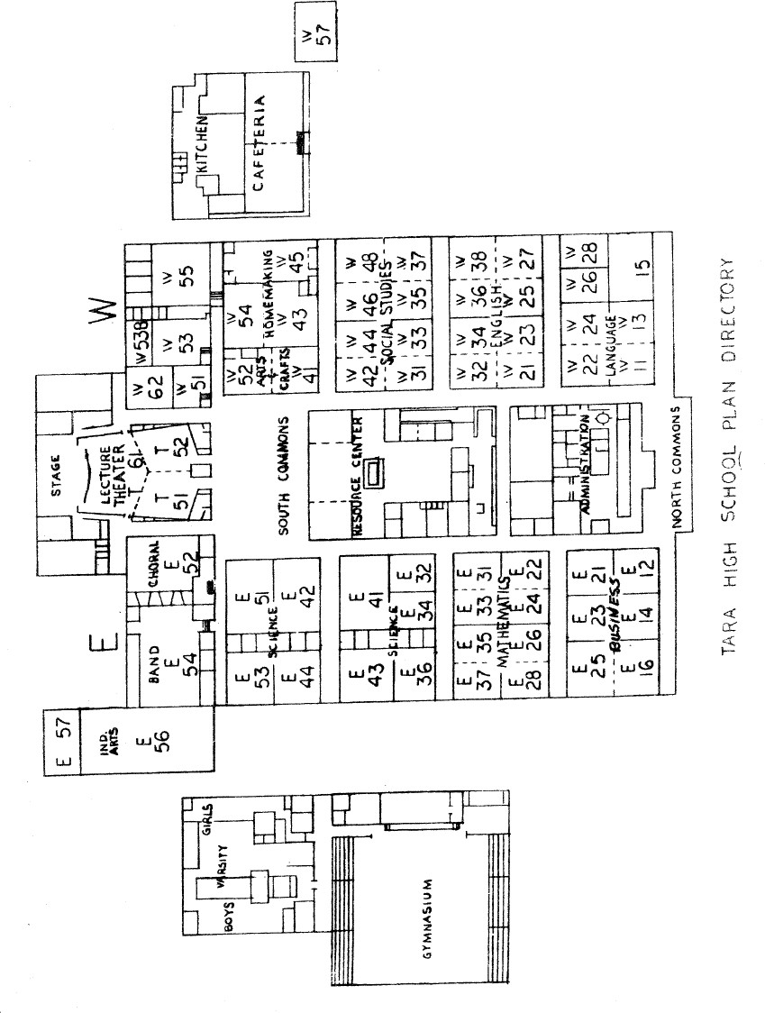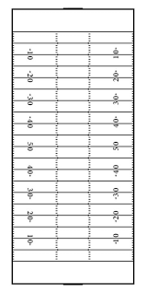

**Stadium West**

**Stadium East**

##### Tara High School Football Field

**East Side:** Exit through the gate to the gym parking lot area

##### Tara High School Gymnasium

**South Side**

**North Side**

**South Side:** Exit through doors on the East side of the gymnasium (Tennis Courts)

**North Side:** Exit through doors in the main entrance of the gymnasium (Gym Parking Lot)



##### Tara High School Softball Field

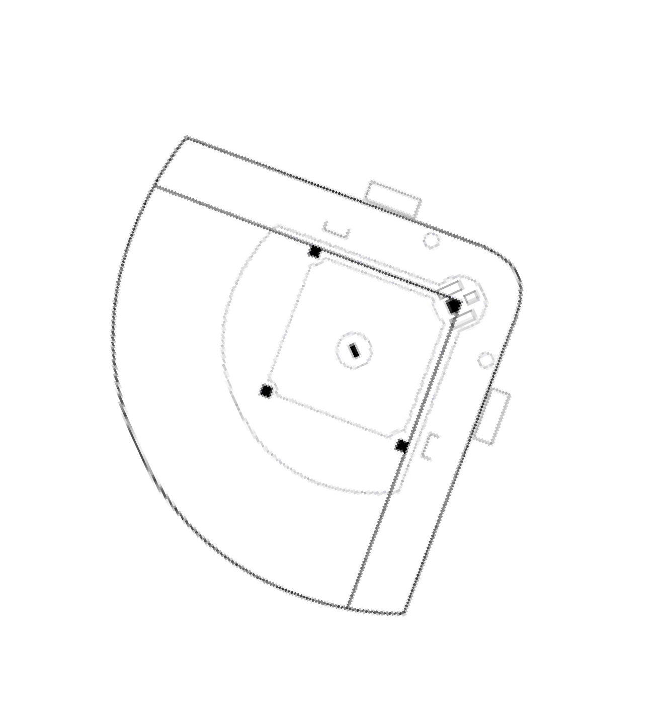

**East Side:** Exit through the gate to the gym parking lot area

##### Tara High School Baseball Field

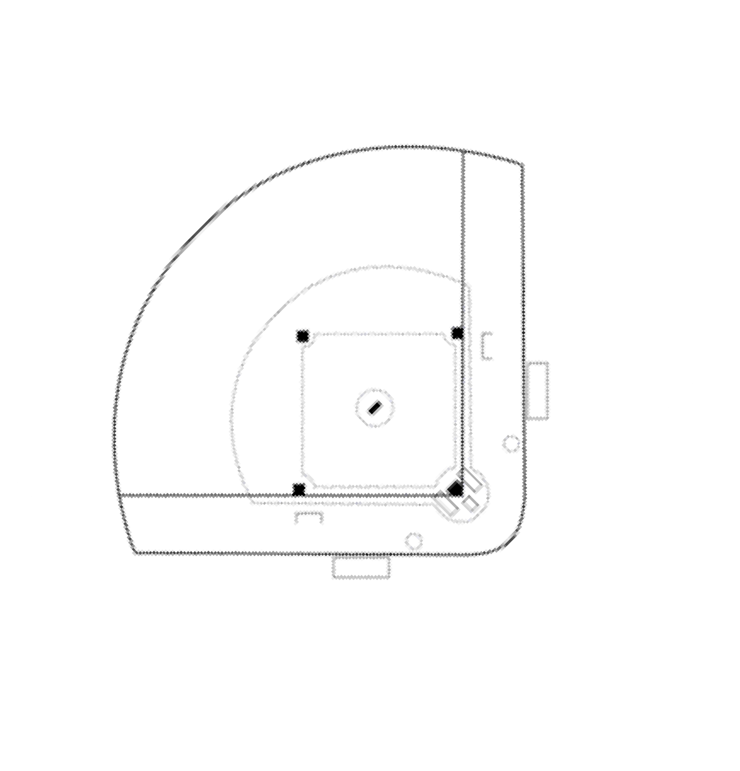

**East Side:** Exit through the gate to ROTC FIELD or ROUNDABOUT

# PROTOCOL AND PROCEDURE FLOW CHART

## School Emergency Plan

**General Instructions**

The response procedures are intended primarily as a ready reference for all staff to be studied and practiced prior to the occurrence of an emergency.

#### INCIDENTS OF VIOLENCE ON CAMPUS

Several of the following emergency scenarios involve an incident of violence on campus. When such an emergency occurs, it is essential that the safety and welfare of students and staff are addressed. This includes the provision of support and counseling immediately and long term. The guidelines below should be followed by the principal and other key personnel.

#### WITHIN 24 HOURS

* Gather the facts
* Ensure appropriate intervention to minimize additional injury
* Provide first aid where necessary
* Ensure the safety and welfare of students and staff
* Set up an Emergency Operations Center, if appropriate
* Contact the District Office to report the critical incident
* Assess the need for support and counseling for those directly and indirectly involved
* Manage the media (Public Information Officer/Principal)
* Set up a recovery room
* Provide information to staff, students, and the school community
* Ensure that the privacy of students and staff is maintained
* Organize assistance such as transportation home

#### WITHIN 48-72 HOURS

* Debrief all relevant persons
* Arrange counseling as needed
* Provide opportunities for staff and students to talk about the incident
* Continue to provide updates to staff, students, and the school community
* Act to dispel rumors
* Restore normal functioning and service delivery as soon as possible
* Where necessary, plan to cover classes, arrange leave, and employ
* Temporary substitute teachers
* Implement protocols for a student or staff member, if required\

#### WITHIN THE FIRST MONTH

* Note student and staff behavioral changes such as reports that individuals cannot sleep, uncharacteristic difficulty coping with work, and/or easily agitated. Where these occur, encourage referral to appropriate support services
* Maintain school contact with hospitalized students and staff

## Abduction/Missing Student

If there has been an abduction, do not confront the suspect. Secure the students in your area and:

* Report an abduction or missing student to the office immediately
* Call 9-1-1 if needed
* Safeguard students under your control
* Have any witnesses remain in the area so law enforcement can speak with them
* Keep the area secure until law enforcement arrives
* Assist law enforcement with anything they need in regard to the student

## Active Shooter/Dangerous Intruder(s)/Student w/ Weapon(s)

In the event of a dangerous intruder:

* No code phrases will be used. Instructions will be clear and concise.
* General Teacher Responsibilities:
* During transition times, teachers should gather nearby students into their classroom
* Close and lock their doors (if possible)
* If the door cannot be locked, prepare to barricade the door (Lock Out) or evacuate (Get Out)
* Students should move out of sight from the hallway
* Lights should be off and window shades should be down
* If the attacker enters your area and you cannot evacuate, fight back with any means
* available as a last resort (Take Out)
* Students who are outdoors should not return to the building. They should evacuate to the nearest off-campus shelter location
* Maintain a calm atmosphere and remain in the locked classroom until the "all- clear" is given.

## Bomb Threat

An evacuation is rarely the safest initial response to a bomb threat. Follow instructions and try to keep your students calm. It is likely that teachers and staff will be asked to search their own areas.

* If you receive the threat, preserve the threat (email, note, etc.) and notify the office.
* Be prepared to communicate all known data regarding the threat to police.
* If the threat was called in, complete the Bomb Threat Call Sheet.
* Emergency Response Team members will be assigned search areas. Teachers and staff will search their own areas.

##### Search instructions for assigned areas:

* Do not turn on lights or disturb anything in the room
* Divide area to be searched in half (based on content, not size)
* Listen out for "ticking" or "clockwork" sounds. If a sound is heard, attempt to visually locate it
* NEVER touch a ticking item. If you cannot locate the ticking device and have concerns, it may be dangerous. Evacuate the room and follow the suspicious object instructions below
* Search your half of the room waist high (around 3 feet) and below first
* Search your half of the room above waist high second

##### If a suspicious object/device is located:

* Notify teachers and staff and have them prepare for evacuation
* Do NOT touch the object
* Person who located the object reports to the Incident Commander
* (Incident Commander will notify the authorities and recall other search teams)
* Secure the area where the item was located, but do not guard it (stay away from the item). If possible and can be done on the way out of the area, open doors and windows near the item.
* Facility leader will determine evacuation route and rally point
* Search teams will re-deploy to search evacuation routes and paths to rally point
* When routes are cleared, assist in evacuation as needed

##### Fire/Fire Alarm/Evacuation

It is not practical to develop a plan for every conceivable reason to evacuate a facility. This guide is to be used if the cause for evacuation does not relate to a specific plan in this guide.

##### Action Plan:

* Listen out for special instructions. These might include unusable exits and the rally point
* Obtain class roster
* Inform students of need to evacuate. Tell them to remain calm & follow instructions
* Immediately scan area outside of your classroom for signs of danger
* If signs of danger are present (smoke/flames) expedite procedures
* If signs of danger are not present proceed in a very calm and orderly manner. Remember the school's Emergency Response Team will be verifying the need to evacuate and attempting to locate any signs of danger throughout the entire campus
* Note any missing students. This information should be shared with an Emergency Response Team Member as soon as possible
* Proceed to the nearest safe exit. Remember the event causing the need to evacuate may block exits
* Listen out for instructions regarding closed exits
* Once outside the school, proceed to the designated rally point
* If possible, avoid parking lots
* Take roll and report missing students
* Remain with your students unless otherwise directed

##### Potential Reasons to Evacuate

* Fire
* Explosion
* Fire Alarm
* Unsafe Structure
* Interior Chemical Release
* Active Shooter*

The primary evacuation route for this room/location is:

The alternate evacuation route for this room/location is:

The evacuation rally point for this room is:

## Hazardous Materials Exterior Release

Notification of exterior hazardous materials release will occur via intercom or word of mouth.

* Close all doors and windows in your area.
* Students will walk as a classroom group to designated safe zones.
* Stay calm. Allow no talking or running.
* See that no student leaves the assigned area or stops at a locker for personal belongings.
* Students in halls, restrooms, nurse's office, and resource centers should proceed to their classrooms or assigned shelter site immediately.
* When your class arrives at its designated area, have students stand quietly and await instructions.
* Report any missing student immediately to a member of the administration.
* Once the "all clear" signal has sounded, return to your classroom.

The assigned safe zone for this room is:

## Medical Emergency

* Notify office (send runner if necessary)
* Office will dispatch Emergency Response Team
* Evaluate and assess injury
* Administer First-Aid **ONLY IF TRAINED**
* Do not move victims unless they are in immediate danger
* When trained help arrives, assist by moving bystanders away
* Write down victim information, ambulance company, and destination

##### Injured persons tracking data:

Name: Grade/Homeroom: Transported by: Transported to:

## Severe Weather

Most severe weather incidents come with a time element warning. Major storms can do and cause severe infrastructure damage to both facilities and utilities requiring either enhanced or major clean-up and restoration efforts. Severe thunderstorms and tornados can be accompanied by high winds, hail, lightning, downed trees, and swollen creeks.

##### An emergency response is required when this type of weather poses any risk to the students or staff.

**A WATCH** is issued when storms are possible in and near the **WATCH** area. It does not mean that they will occur; it only means they are possible. **A WARNING Sign** is issued when storms are

occurring, or imminent, in the **WARNING** area. If a **WARNING** is issued, seek safe shelter immediately. Be prepared to **EVACUATE** to shelter locations.

##### Upon issuance of a warning or danger:

* Secure class roster.
* Students will walk in as a classroom group to assigned areas.
* Stay calm. Allow no talking or running.
* See that no student leaves the assigned area or stops at a locker for personal belongings.
* Students in halls, restrooms, nurse's office, and resource centers should proceed to their classrooms assigned shelter area immediately.
* When your class arrives at its designated area, have students wait quietly and await instructions to drop and cover, if necessary
* Secure any high-value equipment
* 3-4 feet off ground (in case of flooding)
* In interior rooms, secure all books and papers on upper shelves of bookcases.
* Report any missing student immediately to a member of the administration. Be sure to keep your class together.
* Once the "all clear" signal has sounded, return to your classroom

The assigned shelter area for this room is:

## Threat of Violence/Heightened Security Measures

Threats of violence can occur when a belligerent or armed person on the school campus bullies, intimidates, or coerces others and targets an individual, group, or the entire school. Threats of violence are presented as overt hostility.

Notes: All entrances will be locked, outdoor activities will be cancelled, and hallway access may be restricted.

* Assist as directed in the recalling all outdoor students.
* Restrict hallway activity.
* Ensure assigned entrances are secure.
* Monitor entrances as assigned.
* Be prepared to implement full intruder response/lockdown procedures.

##### Action Plan:

* Students should report immediately to their classroom.
* All internal doors will be locked by teachers.
* Students outdoors should report to the gymnasium or locker room area.
* Students should not be allowed to leave the classroom or the building.
* Students will not change classes if the bell should ring during this time.
* Teachers should maintain a calm atmosphere and remain in the classroom until the "All-Clear" signal is announced.

## Emergency Contact Numbers / Alert Stations

##### Referrals State / National Parish / Local

* Help Line for Louisiana Emergency Numbers 225-342-6600 211

##### Crisis Intervention

* Rape Crisis Hotline 800-656-4673 383-7273
* Suicide Prevention 225-924-3900 225-924-3900
* I Care Crisis Counseling Services 225-226-2273 225-226-2273

##### Victim Assistance

* Child Abuse/Neglect Reporting Line 225-925-4571 925-4571
* Runaway Hotline (for students) 800-621-4000 343-6300
* National Center for Missing/Exploited Children (for parents) 800-843-5678
* Crime Victims Bureau 888-342-6110 389-8321
* Domestic Violence Hotline 800-799-7233 389-4705
* Hazardous Materials/Poison
* Hazardous Materials Leak or Spill 877-925-6595 389-3860
* Poison Control Center 800-256-9822
* Emergency Management Agencies
* Office of Emergency Preparedness 800-256-7036 389-3035 Use the following table to list other important Parish numbers. **Agency Primary Number Secondary Number**
* Fire 911
* EMS 911
* Police 911 / 389-2000
* Sheriff 911 / 389-5000
* Energy 800-368-3749
* Office of Emergencies Preparedness 389-3035
* Local Red Cross 225-291-4533
* Mayor 389-3100
* Drug Hotline 1-800-622-HELP

##### Local Hospital

* Baton Rouge General (Bluebonnet 8565 Picardy Ave

Baton Rouge, LA 70809

225-763-4000

* Our Lady of The Lake 5000 Hennessy Blvd Baton Rouge, LA 70808 225-765-6565
* Lane Memorial (Zachary) 6300 Main St

Zachary, LA 70891

225-654-4000

## Important Incident Phone Numbers

|  |  |
| --- | --- |
| Security Department  Dionne Chaney - Supervisor | (225) 436-0065 |
| Sean Joffrion - Supervisor of Fine Arts/H&PE/Athletics | (225) 288-7326 |
| EBRPSS Security Communication Center | (225) 226-7690 |
| Night Security | (225) 226-3702 |
| Patrick Ficklin (HES) | (225) 975-0041 |
| Ms. Leslie (HES) Maintenance Staff | (225) 678-2175 |
| Ms. Shelita (HES) Custodial Staff | (225) 394-5677 |
| School Drug Task Force | (225) 239-7841 |

**Note:** Always call Security first, then your area Superintendent. If contact is not made with the first two calls, then call the Superintendent’s Office. Security and/or your Area Superintendent will contact the Superintendent’s Office.

# EMERGENCY ACTION PLAN (EAP)

**Tara High School** has written an emergency action plan to be followed in the event of a medical emergency. All Coaches should be familiar with this document and their role and responsibility in an emergency. Any questions should be directed to the Head Athletic Trainer (or School Administrator in the absence of a licensed Athletic Trainer).

An ***emergency*** is the need for Emergency Medical Services (EMS) to give further medical attention and/or transport an athlete to the hospital. It is important in these situations that coordination between Athletic Trainers, Coaches, School administrators and student responders to be effective. This guide is to delineate roles and outline the protocols to be followed should an emergency event occur.

##### Situations 911 should be called:

* an athlete is not breathing
* an athlete has lost consciousness
* it is suspected that the athlete may have a neck or back injury
* athlete has an open fracture (bone has punctured through the skin)
* severe heat exhaustion or suspected heat stroke
* severe bleeding that cannot be stopped

Chain of Command Team Physician Certified Athletic Trainer School Resource Officer Athletic Director

School Administrator Head Coach Assistant Coach

Sports Medicine Student

Other Athletes

The highest person in this chain of commands is who is present at the scene will be the person in charge, or leader. That person is responsible for deciding whether to call 911, instructing others how they can be of help and will be the person who stays with the athlete until EMS arrives. Once it has been decided that EMS should be called the following protocol should be followed:

1. The highest person on the chain of commands will be deemed the leader and will stay with the athlete to monitor the athlete’s condition and administer necessary first air. If possible, someone else on the chain of command should also stay and assist. The front office or an administrator should be notified that there is an emergency on campus.
2. The highest person on the chain of command will make the call to EMS or will designate another person to make the call. (911 from a cell phone or school landline). EMS should be told what the emergency is, the condition of the athlete and how to get where the athlete is. Also, tell EMS that someone will meet them at the closest intersection to aid in directing the ambulance. **DO NOT HANG UP UNTIL EMS HANGS UP FIRST**.
3. Phones at Tara High School are in the main office, administrative offices and AD’s office in the gym. All members of the chain of command should always have a cellular phone with them.
4. The leader will send runners to all intersections between where the athlete is located and the front of Tara High School to direct the ambulance to the athlete. The runners should stay in their positions and wave the ambulance through the proper turns to get to the athlete.
5. The leader will designate another person to attempt contact with the athlete’s parents. Emergency contact information can be found with the head coach/sponsor, and they should always have this with them. If a parent is not present, the emergency contact information and any pertinent medical information should accompany the athlete to the hospital.
6. If transport is deemed necessary by EMS, the athlete will be taken to Ochsner Medical Center of Baton Rouge (O’Neal) at 17000 Medical Center Drive unless the parent requests otherwise.

##### Tara High School is located at: 9002 Whitehall Ave

**Baton Rouge, LA 70806**

Directions from Airline highway, turn west on Old Hammond Highway, right on Tara Blvd, and then right on Whitehall Ave.

##### Location of AED

At Tara High School, the AED is mounted in the southwest corner of the gym. **Coaches should take note of the AED location in accordance with practices and game locations.**

##### Important Phone Numbers

**Athletic Trainer: On Duty EMS:** 911

**Main Office:** 225-927-6100

**Athletic Director (Melvin Hill):** 225-993-6297 (cell)

**Principal (John Hayman):** 225-361-7978 (cell)

**Assistant Principal (Jessica Mitchell):** 225-772-5557 (cell) **Assistant Principal (Cara Coleman):** 225-205-4273 **Assistant Principal (John Robinson):** 225-636-0536

**Ochsner O’Neal Hospital Emergency Department:** 225-752-2470

##### ZONE 1 (Gymnasium, Outside Basketball Courts, Boys and Girls Main Locker Rooms, Softball Field, and Coaches Offices)

**EMS Route:** From Airline highway turn west on Old Hammond Highway, right on Tara Blvd, right on Whitehall Ave, and then right into the last school parking lot after the Tara High School sign and before the left bend in the road.

**AED Location:** The AED is mounted on the southwest corner of the gym.

##### ZONE 2 (Weight Room, Football Practice Field, Track, Baseball Field and Locker Room)

**EMS Route:** From Airline highway turn west on Old Hammond Highway, right on Tara Blvd, right on Whitehall Ave, immediate right onto Oakley Dr, and turn into the school parking lot on the left.

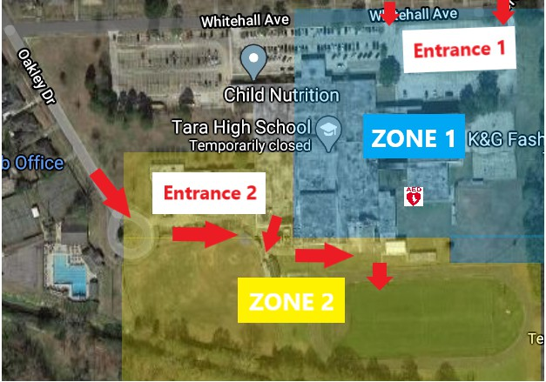**AED Location:** The AED is mounted on the southwest corner of the gym.

## Baseball Field (Include map below) Emergency Action Plan

**Important Phone Numbers: Athletic Trainer On Duty**

**Head Baseball Coach (Donald Langford):** 337-853-2968

**EMS:** 911 or 9-911 if calling from a school phone

**Main Office:** 225-927-6100

**Athletic Director (Melvin Hill):** 225-993-6297 (cell); 225-927-2304 (Office)

**Ochsner O’Neal Hospital Emergency Department:** 225-752-2470

**Game and Practice Site Street Address:**

9002 Whitehall Ave, Baton Rouge, LA 70806

**Directions for EMS:**

From Airline highway turn west on Old Hammond Highway, right on Tara Blvd, right on Whitehall Ave, immediate right onto Oakley Dr, and turn into the school parking lot on the left. (Make sure to have a runner at each intersection starting at Whitehall Ave)

**AED Location**:

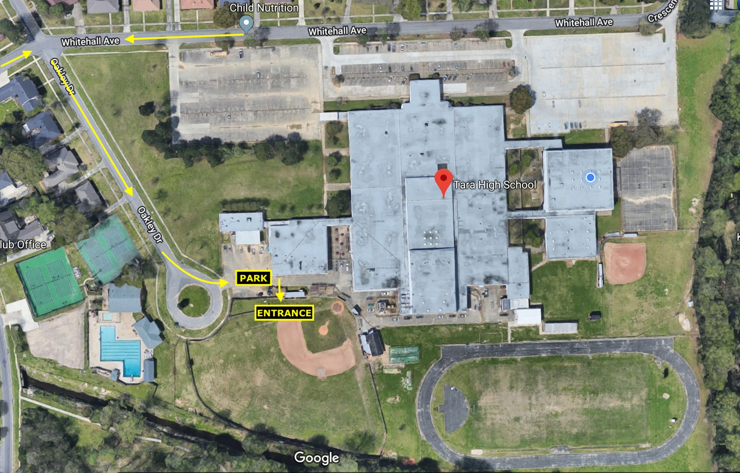Mounted on the southwest wall of the gym

**Practice Field & Track (Include map below) Emergency Action Plan**

**Important Phone Numbers: Athletic Trainer On Duty**

**Head Football Coach (Lawrence Brown): 225-485-4816**

**Head Soccer Coach (Keith Buras):** TBD

**EMS:** 911 or 9-911 if calling from a school phone

**Main Office:** 225-927-6100

**Athletic Director (Melvin Hill):** 225-993-6297 (cell); 225-927-2304 (Office)

**Ochsner O’Neal Hospital Emergency Department:** 225-752-2470

**Game and Practice Site Street Address:**

9002 Whitehall Ave, Baton Rouge, LA 70806

**Directions for EMS:**

From Airline highway turn west on Old Hammond Highway, right on Tara Blvd, right on Whitehall Ave, immediate right onto Oakley Dr, and turn into the school parking lot on the left. (Make sure to have a runner at each intersection starting at Whitehall Ave)

**AED Location**:

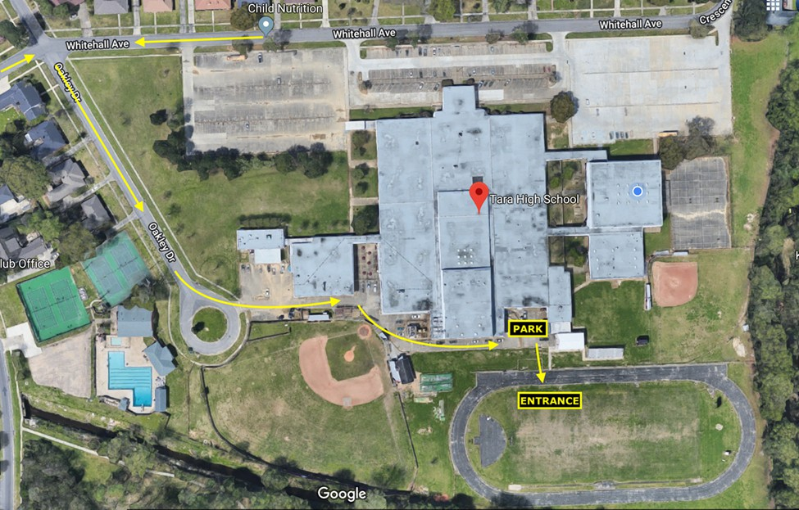Mounted on the southwest wall of the gym

**Emergency Action Plan**

### Important Phone Numbers: Athletic Trainer On Duty

**Powerlifting Head Coach (Donald Burnette):225 EMS:** 911 or 9-911 if calling from a school phone **Main Office:** 225-927-6100

**Athletic Director (Melvin Hill):** 225-993-6297 (cell); 225-927-2304 (Office)

**Ochsner O’Neal Hospital Emergency Department:** 225-752-2470

### Practice Site Street Address:

9002 Whitehall Ave, Baton Rouge, LA 70806

### Directions for EMS:

From Airline highway turn west on Old Hammond Highway, right on Tara Blvd, right on Whitehall Ave, immediate right onto Oakley Dr, and turn into the school parking lot on the left. (Make sure to have a runner at each intersection starting at Whitehall Ave)

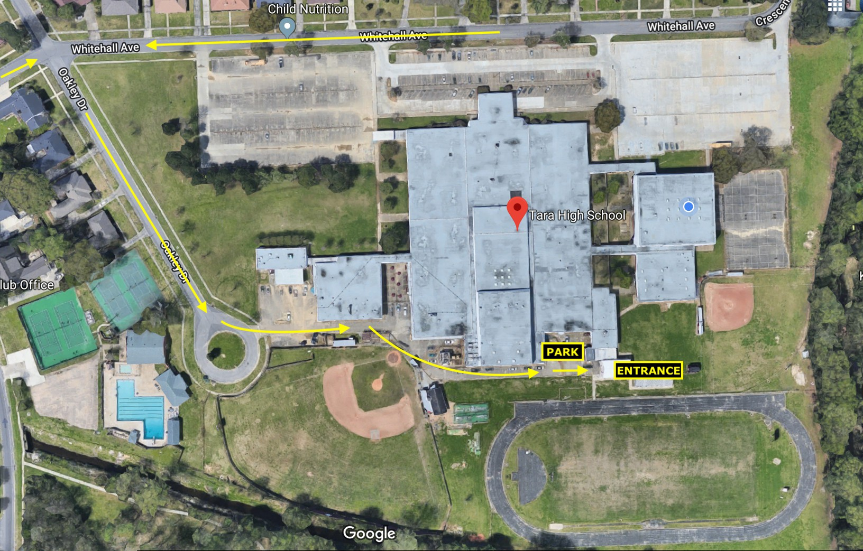Mounted on the southwest wall of the gym

**Softball Field (Include map below) Emergency Action Plan Important Phone Numbers:**

##### Athletic Trainer On Duty

**Head Softball Coach (Barry Jackson):** 225-281-9327 (cell); 225-927-0335 (Office)

**EMS:** 911 or 9-911 if calling from a school phone

**Main Office:** 225-927-6100

**Athletic Director (Melvin Hill):** 225-993-6297 (cell); 225-927-2304 (Office)

**Ochsner O’Neal Hospital Emergency Department:** 225-752-2470

##### Game and Practice Site Street Address:

9002 Whitehall Ave, Baton Rouge, LA 70806

##### Directions for EMS:

From Airline highway turn west on Old Hammond Highway, right on Tara Blvd, right on Whitehall Ave, and then right into the last school parking lot after the Tara High School sign and before the left bend in the road. (Make sure to have a runner at each intersection starting at Whitehall Ave).

##### AED Location:

Mounted on the southwest corner of the gym

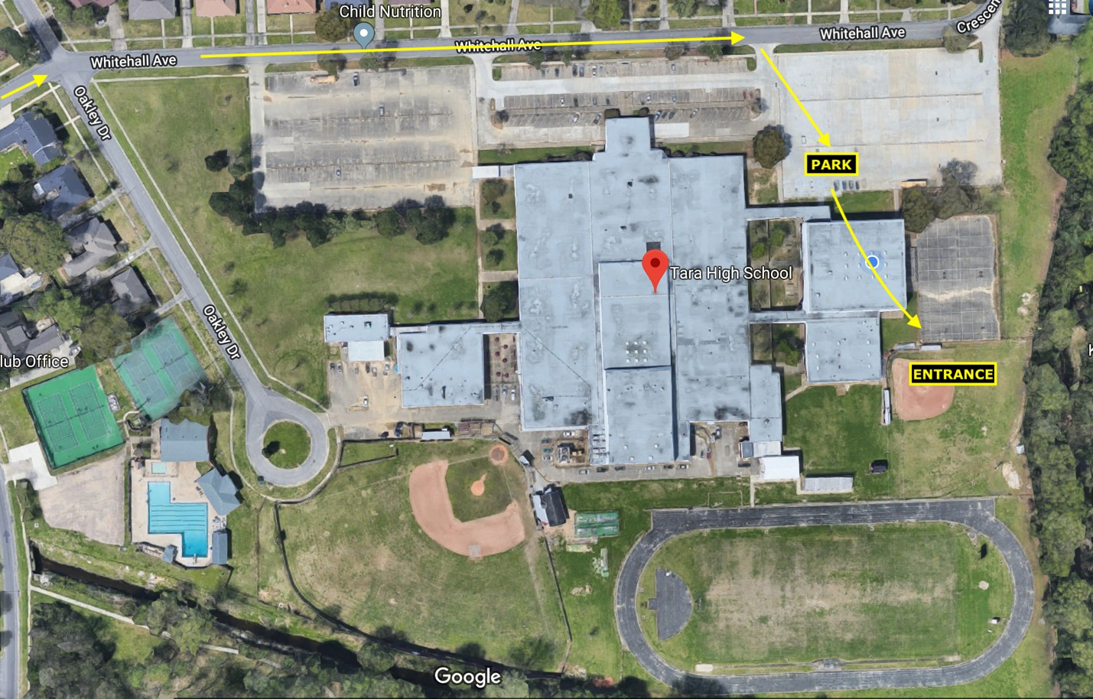

**All Star Lanes (Include map below) Emergency Action Plan**

**Important Phone Numbers: Athletic Trainer On Duty**

**Head Bowling Coach (Walter Cressy)**

**EMS:** 911 or 9-911 if calling from a school phone

**Main Office:** 225-927-6100

**Athletic Director (Melvin Hill):** 225-993-6297 (cell); 225-927-2304 (Office)

**Ochsner O’Neal Hospital Emergency Department:** 225-752-2470

**Game and Practice Site Street Address:**

9829 Airline HWY, Baton Rouge, LA 70816

**Directions for EMS:**

On Airline HWY next to the Neighborhood Walmart and FedEx (Make sure to have a runner outside at the road and entrance to the building).

**AED Location**:

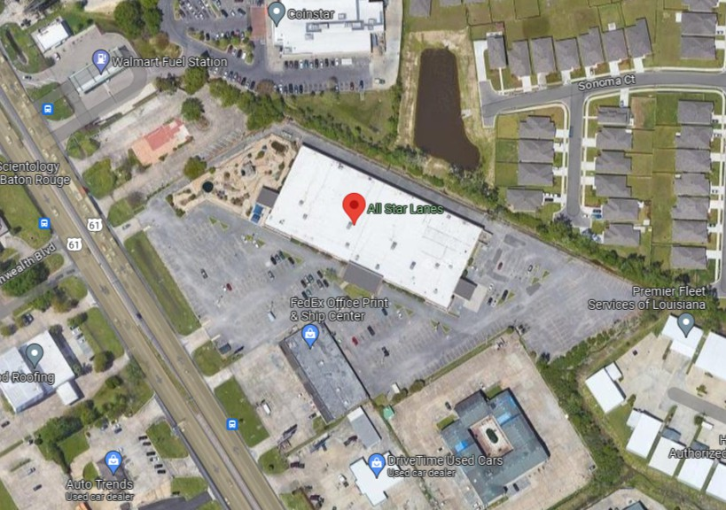Follow site specific instructions.

## Wet Bulb Globe Temperature Guidelines

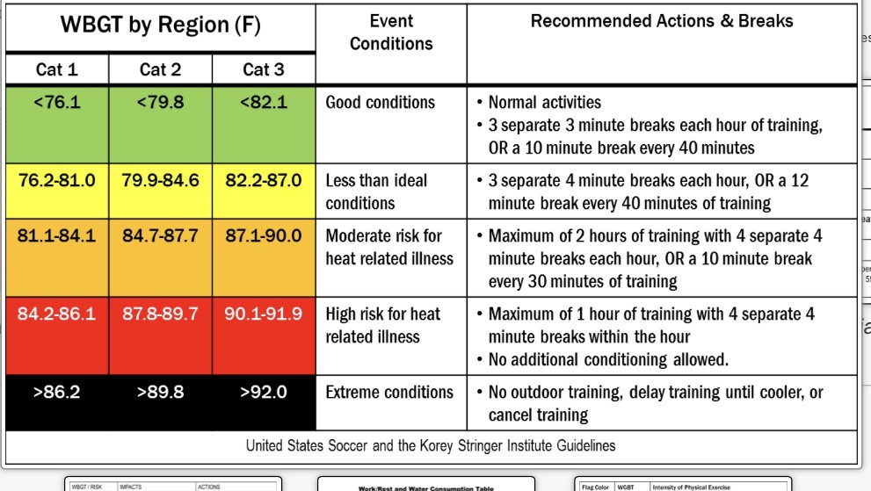

**We are Category 3

**Wet Bulb Globe Temperature Best Practices**

1. Schedule practices during certain times using the various Wet Bulb Globe Temperature (WBGT) levels.
2. The ratio of workout time allotted for rest and hydration during various WBGT levels will result in modified or terminated practice(s) or contest(s) in consideration of safe playing conditions.
3. Rest time should involve unrestricted access to fluids such as water or electrolyte beverages.
4. Sports/Activity requiring helmets, including but not limited to football, baseball, lacrosse, and field hockey, should be removed during rest time.
5. The site for rest time should be in a shaded area.
6. When the WBGT reading is >85.0°, cold-water immersion tubs or equivalent should be available to aid in the cooling process within the shaded area. a. An instrument

approved to measure WBGT must be utilized at each outdoor practice. WBGT readings should be taken at the practice site for a minimum of every hour, beginning 30 minutes before the start of practice or contest. All readings should be recorded, or data logged in either written or electronic form.

* 1. If a modification or cancellation is required, documentation using the WBGT Environment Modification/Cancellation Log must be completed
  2. In the event of potential Exertional Heat Stroke (EHS), each school participating in interscholastic sports/activity must be properly prepared and equipped to initiate Cold Water Immersion (CWI) or Cold Tub. Cooling techniques must be implemented immediately, and EMS concurrently contacted, noting that the focus is to cool first and then transport.
  3. The best practices shall be carried out by a licensed athletic trainer, designated healthcare provider, or individual appointed by the athletic director

**Heat Related Illness**

*Heat Cramps*

* What is it?
  + Mildest stage of heat illness
* Symptoms:
  + Excessive sweating, muscle pain, spasms, cramping
* Intervention:
  + Move to a cool place (indoors or in shade if possible)
  + Hydrate with water and electrolytes; massage
* Return?
  + When cramps have subsided, and the athlete can jog without cramping again

*Heat Exhaustion*

* What is it?
  + Intermediate stage, not a medical emergency
* Symptoms:
  + Excessive sweating; cold, pale, and clammy skin; fast and weak pulse; nausea and vomiting; dizziness, headache, or fainting
* Intervention:
  + Move to a cool place (cold water immersion tub if possible)
  + Remove socks, shoes, head covering, and shirt. SIP water.
* Return:
  + No same day returns. Reassess the following day.

*Heat Stroke*

* What is it?
  + Medical emergencies- activate the emergency action plan
* Symptoms:
  + High body temp (exceeds 105 degrees).
  + hot, red, and dry skin.
  + fast, strong pulse; headache, dizziness, confusion, fainting, and nausea.
* What to expect?
  + Fighting in the tub
* Intervention:
  + Activate the emergency action plan, no liquids, cold water immersion tub
* Return:
  + When cleared by a physician Cold Water Immersion Tub:
* First, add cool water ONLY. After a few minutes slowly add ice. Move water around by using the sides of the athlete for about 5 minutes.
  + DO NOT add ice immediately- you can send the athlete into shock.